Exp.No:37
37. Using OpenCV play Video in Reverse mode.

Aim:
To read and play a video in reverse order using OpenCV.
Procedure:
- Open the video using OpenCV.
- Read all the frames.
- Store the frames in a list.
- Reverse the order of the frames.
- Display the frames in reverse order.
- Save the reversed video.
- Stop the program.
Program:
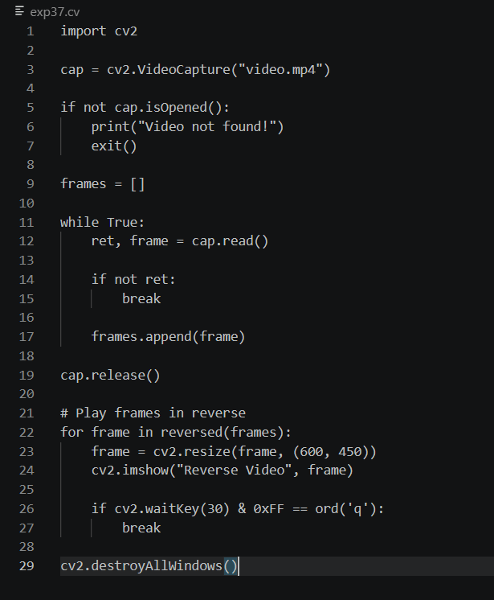

Output:
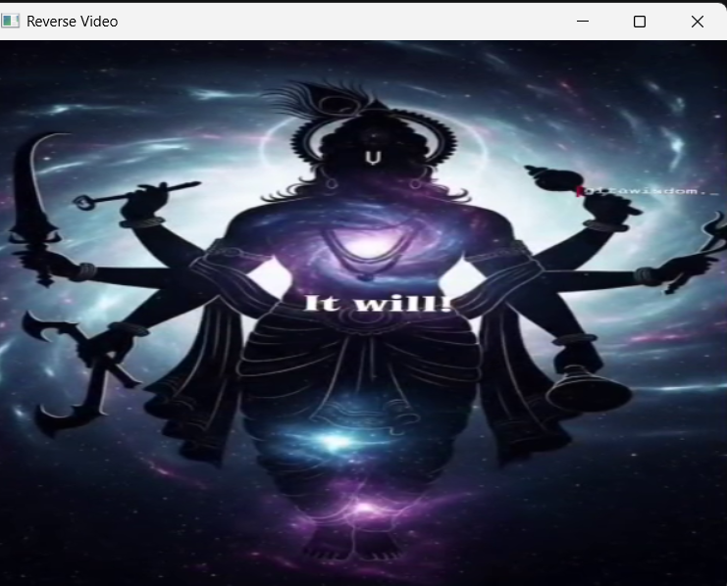

Result:
The video was successfully played in reverse mode using OpenCV.

